***AIDS MICROPROCESSOR LAB S21 BATCH (2023-24)***

***Experiment 12 Title: Assembly language programming to calculate the cube of given number using macro.***

***Name of student: Meet Raut Class Roll Number: 2201084***

***Date of Performance: 01/04/2024***

***Batch: S2-1 Timing: 3:00-5:00 Date of Submission: -01/04/2024***

***Assembly language code***

*DATA_SEG SEGMENT*

*number DW 5 #Variable to store the number*

*result DW ? #Variable to store the result*

*DATA_SEG ENDS*

*CODE_SEG SEGMENT*

*ASSUME CS:CODE_SEG, DS:DATA_SEG*

*cube_macro MACRO #Define a macro to calculate the square of a number*

*MOV AX,number #Copy contents of number into AX register*

*MOV BX,number #Copy contents of number into BX register*

*MUL AX #Multiply AX by itself (square)*

*MUL BX*

*ENDM*

*START:*

*MOV AX,DATA_SEG #Initialize the data segment*

*MOV DS,AX*

*cube_macro #Call the macro*

*MOV result,AX #Store the result*

*MOV AH,4Ch #Exit to DOS*

*INT 21h # Call DOS interrupt*

*CODE_SEG ENDS*

*END START*

*Result:*

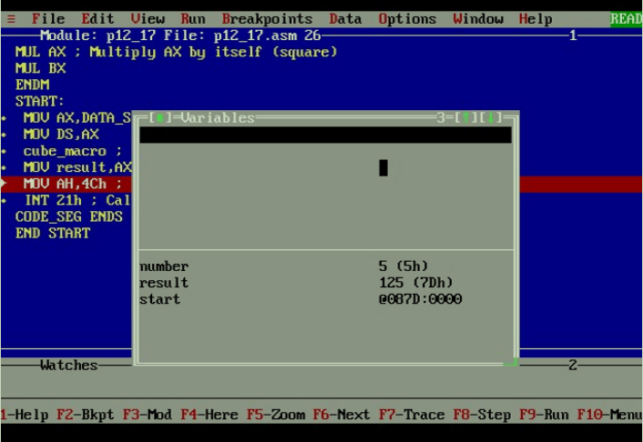

*CONCLUSION: LO 2, LO 3 mapped.*

***---------------------------------*****************************-----------------------------------***